- Tell me about CI/CD pipeline use case in your project.
- What databases you have worked on?
- What is exceptional handling in lambdas (try except finally block)?
try: This block contains the code that might raise an exception. If an exception occurs, the control is passed to the except block.
except: This block catches and handles the exception. You can specify different types of exceptions to handle specific errors.
finally: This block contains code that will run no matter what, whether an exception was raised or not. It's typically used for cleanup actions.
The try block attempts to execute some_function(event).
If a ValueError occurs, it's caught by the first except block.
Any other exceptions are caught by the second except block.
The finally block runs regardless of whether an exception was raised, ensuring that any necessary cleanup is performed.

- What are some default exceptions in python (e.g.: typeerror, zerodivision etc)?
  - TypeError: Raised when an operation or function is applied to an object of inappropriate type.
  - x = "hello" + 5 # Raises TypeError
  - ZeroDivisionError: Raised when division or modulo by zero takes place.
  - y = 10 / 0 # Raises ZeroDivisionError
  - ValueError: Raised when a function receives an argument of the right type but inappropriate value.
  - int("abc") # Raises ValueError
  - IndexError: Raised when a sequence subscript is out of range.
  - lst = [1, 2, 3]
  - print(lst[5]) # Raises IndexError
  - KeyError: Raised when a dictionary key is not found.
  - d = {'a': 1}
  - print(d['b']) # Raises KeyError
  - AttributeError: Raised when an attribute reference or assignment fails.
  - obj = None
  - obj.some_method() # Raises AttributeError
  - ImportError: Raised when an import statement fails to find the module definition or when a from ... import fails to find a name that is to be imported.
  - import non_existent_module # Raises ImportError
  - FileNotFoundError: Raised when a file or directory is requested but doesn't exist.
  - open('non_existent_file.txt’) # Raises FileNotFoundError
  - IOError: Raised when an I/O operation (such as a print statement, the open() function, etc.) fails for an I/O-related reason.
  - open('/path/to/file', 'r’) # Raises IOError if the file cannot be opened
  - RuntimeError: Raised when an error is detected that doesn’t fall in any of the other categories.
raise RuntimeError("This is a runtime error") # Raises RuntimeError

- How will s3 and lambda application work (tell about using SQS and DLQ as processing data directly from s3 may result in some data loss in lambda)?
S3 and Lambda Integration
- S3 Trigger: You can configure an S3 bucket to trigger a Lambda function whenever a new object is created. This is done by setting up an event notification on the S3 bucket.
Lambda Function: The Lambda function processes the data from the S3 event. For example, it can read the file, transform the data, and store the results in another service.
Using SQS and DLQ
- SQS (Simple Queue Service):
  - Buffering: Instead of processing data directly from S3, you can use SQS as a buffer. When an object is created in S3, an event is sent to an SQS queue.
  - Lambda Trigger: Lambda is configured to poll the SQS queue and process messages. This decouples the S3 event from the Lambda processing, allowing for better error handling and retries
.
- DLQ (Dead Letter Queue):
  - Error Handling: If the Lambda function fails to process a message from the SQS queue after a certain number of retries, the message is moved to a DLQ. This ensures that problematic messages are not lost and can be reviewed and reprocessed later
.
  - Debugging: DLQs help in debugging by isolating failed messages, allowing you to identify and fix issues without affecting the main processing flow
.
Workflow Example
- S3 Event: A file is uploaded to an S3 bucket.
- S3 Notification: S3 sends an event notification to an SQS queue.
- SQS Queue: The event is stored in the SQS queue.
- Lambda Polling: Lambda polls the SQS queue, retrieves the event, and processes the file.
- Error Handling: If Lambda fails to process the message, it retries a few times. If it still fails, the message is moved to the DLQ for further investigation.
This setup ensures that your data processing is robust and can handle failures gracefully, reducing the risk of data loss.

- What is re-partitioning and coalescing in PySpark?
In PySpark, re-partitioning and coalescing are techniques used to manage the number of partitions in a DataFrame or RDD. These operations help optimize the performance of your Spark jobs by controlling the distribution of data across the cluster.
Re-partitioning
- Purpose: To increase or decrease the number of partitions.
- Usage: repartition(numPartitions)
- When to Use:
  - When you need to increase the number of partitions to parallelize operations and improve performance.
  - When you want to shuffle data across the cluster to balance the load.
- Example:
- df = df.repartition(10) # Increase the number of partitions to 10
Coalescing
- Purpose: To decrease the number of partitions without a full shuffle.
- Usage: coalesce(numPartitions)
- When to Use:
  - When you need to reduce the number of partitions, typically after a filter operation that significantly reduces the dataset size.
  - When you want to avoid the overhead of a full shuffle.
- Example:
- df = df.coalesce(2) # Reduce the number of partitions to 2
Key Differences
- Re-partitioning involves a full shuffle of the data across the cluster, which can be expensive but ensures an even distribution of data.
- Coalescing avoids a full shuffle by merging partitions, which is more efficient but may result in unevenly sized partitions.
These techniques are essential for optimizing the performance of your Spark jobs by ensuring that data is evenly distributed and that the number of partitions is appropriate for the size of your dataset and the resources available in your cluster.

- Suppose you have a step function where one lambda is generating large file and after process completion other lambda is processing that file through FTP but due to large file size lambda timeouts and fails. How will you handle this (use AWS Glue which works on python and lambda)
Step-by-Step Solution
- Generate the Large File with Lambda:
  - Use a Lambda function to generate the large file and store it in an S3 bucket.
- Trigger AWS Glue Job:
  - Instead of processing the file directly with another Lambda, trigger an AWS Glue job to handle the processing. AWS Glue is designed for ETL (Extract, Transform, Load) tasks and can handle large datasets efficiently.
- AWS Glue Job Configuration:
  - Script: Write a Python script for the AWS Glue job to process the file. This script can include reading the file from S3, processing the data, and then uploading the processed data back to S3 or another destination.
  - Job Configuration: Configure the job with appropriate resources (e.g., worker type, number of workers) to handle the file size.
- Use AWS Step Functions:
  - Workflow Orchestration: Use AWS Step Functions to orchestrate the entire process. The workflow can include steps to generate the file, trigger the AWS Glue job, and handle any post-processing tasks.
  - Error Handling: Implement error handling in the Step Functions workflow to manage retries and failures. If the AWS Glue job fails, you can configure the workflow to retry the job or send notifications.
- Dead Letter Queue (DLQ):
  - Error Management: Configure a DLQ for the AWS Glue job to capture any failed processing attempts. This ensures that you can review and reprocess failed tasks without losing data.
Example Workflow
- Step 1: Lambda function generates the large file and stores it in S3.
- Step 2: Step Functions triggers an AWS Glue job to process the file.
- Step 3: AWS Glue job reads the file from S3, processes it, and stores the result back in S3.
- Step 4: Step Functions checks the status of the AWS Glue job. If successful, proceed to the next step; if failed, handle the error (e.g., retry or send to DLQ).

- Types of AWS Glue jobs definition
- Concurrency in AWS Lambda
- boto3
Boto3 is the Amazon Web Services (AWS) Software Development Kit (SDK) for Python. It allows Python developers to interact with AWS services like Amazon S3, Amazon EC2, Amazon DynamoDB, and more. Here are some key features:
  - Ease of Use:
    - Boto3 provides a set of libraries that are consistent and familiar for Python developers, making it easy to call AWS services using idiomatic Python APIs.
  - Service Integration:
    - You can build applications that work with various AWS services, such as creating and managing S3 buckets, launching EC2 instances, and querying DynamoDB tables.
  - Advanced Features:
    - Pagination: Handles paginated results seamlessly.
    - Waiters: Automatically poll for predefined status changes in AWS resources.
    - Service-Specific Features: Includes features like automatic multi-part transfers for S3 and simplified query conditions for DynamoDB.
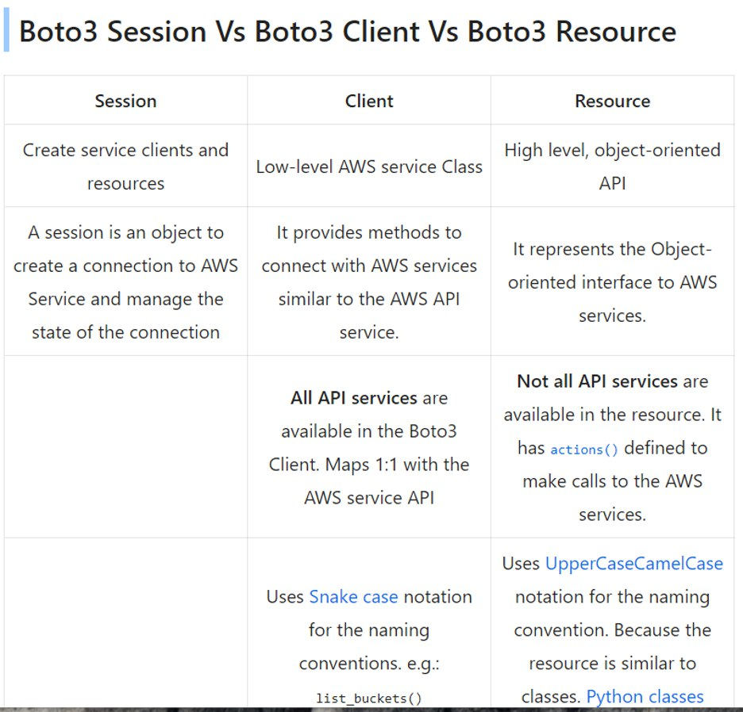

- normal and keyword arguments in python and their limitations
- T1 : C1|
a|
b|
c|
T2 : C2|
2|
1|
3|
output required: C1|C2
a|2
b|1
c|3
- Write a python program to print "hello" if divisible by 3 and "world" if divisible by 5 and print "hello world" if divisible by both 3 and 5.
- json.dump and json.load.
json.dump: Converts a Python object into a JSON string and writes it to a file.
json.load: Reads a JSON string from a file and converts it into a Python object.

- Stack and heap memory storage in python.
- Call by value and call by reference in python.
- Suppose you have Employee table which has employee_ids, write a SQL query to fetch duplicate employee_ids and non-duplicate employee_ids count and print it in SQL select statement
- How to rename a file in PySpark?
- Find count of vowels and consonants in a given string using python
- Error handling in Lambda

Briefly explain about your IT industry experiences
- What is Higher order function in python
- Write a python program to find the sum of combination equals to length of integer
ex- 123456 (1,5) (2,4)
- Write a python program to print "hello" if divisible by 3 and "world" if divisible by 5 and print "hello world" if divisible by both 3 and 5
- What is CDK in AWS?
- What is UUID in python and add in existing table ?
- How to identify lambda is not trigger even after S3 events trigger?
- What is DLQ in AWS?
- What is SNS Topics?
- How to validate Column header using PySpark?
- T1 : C1|
a|
b|
c|
T2 : C2|
2|
1|
3|
output required: C1|C2
a|2
b|1
c|3
- What is AWS API Gateway?
- Difference between SQS and SNS.

